User’s Documentation Guidelines

This document is the intellectual property of the author.

Created for classes C++ at MFF UK.

## Compilation

Application was compiled and tested with: Visual Studio 2019, OS Windows 10 64-bit, CPU intel core i7, RAM 8GB

## Guide

Aplication can be runned from command line. Aplication provides two basic commands and options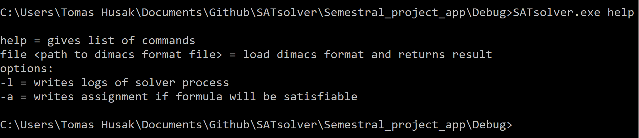

figure 1 - help command

. Choose command file for solving formula. You can add some options.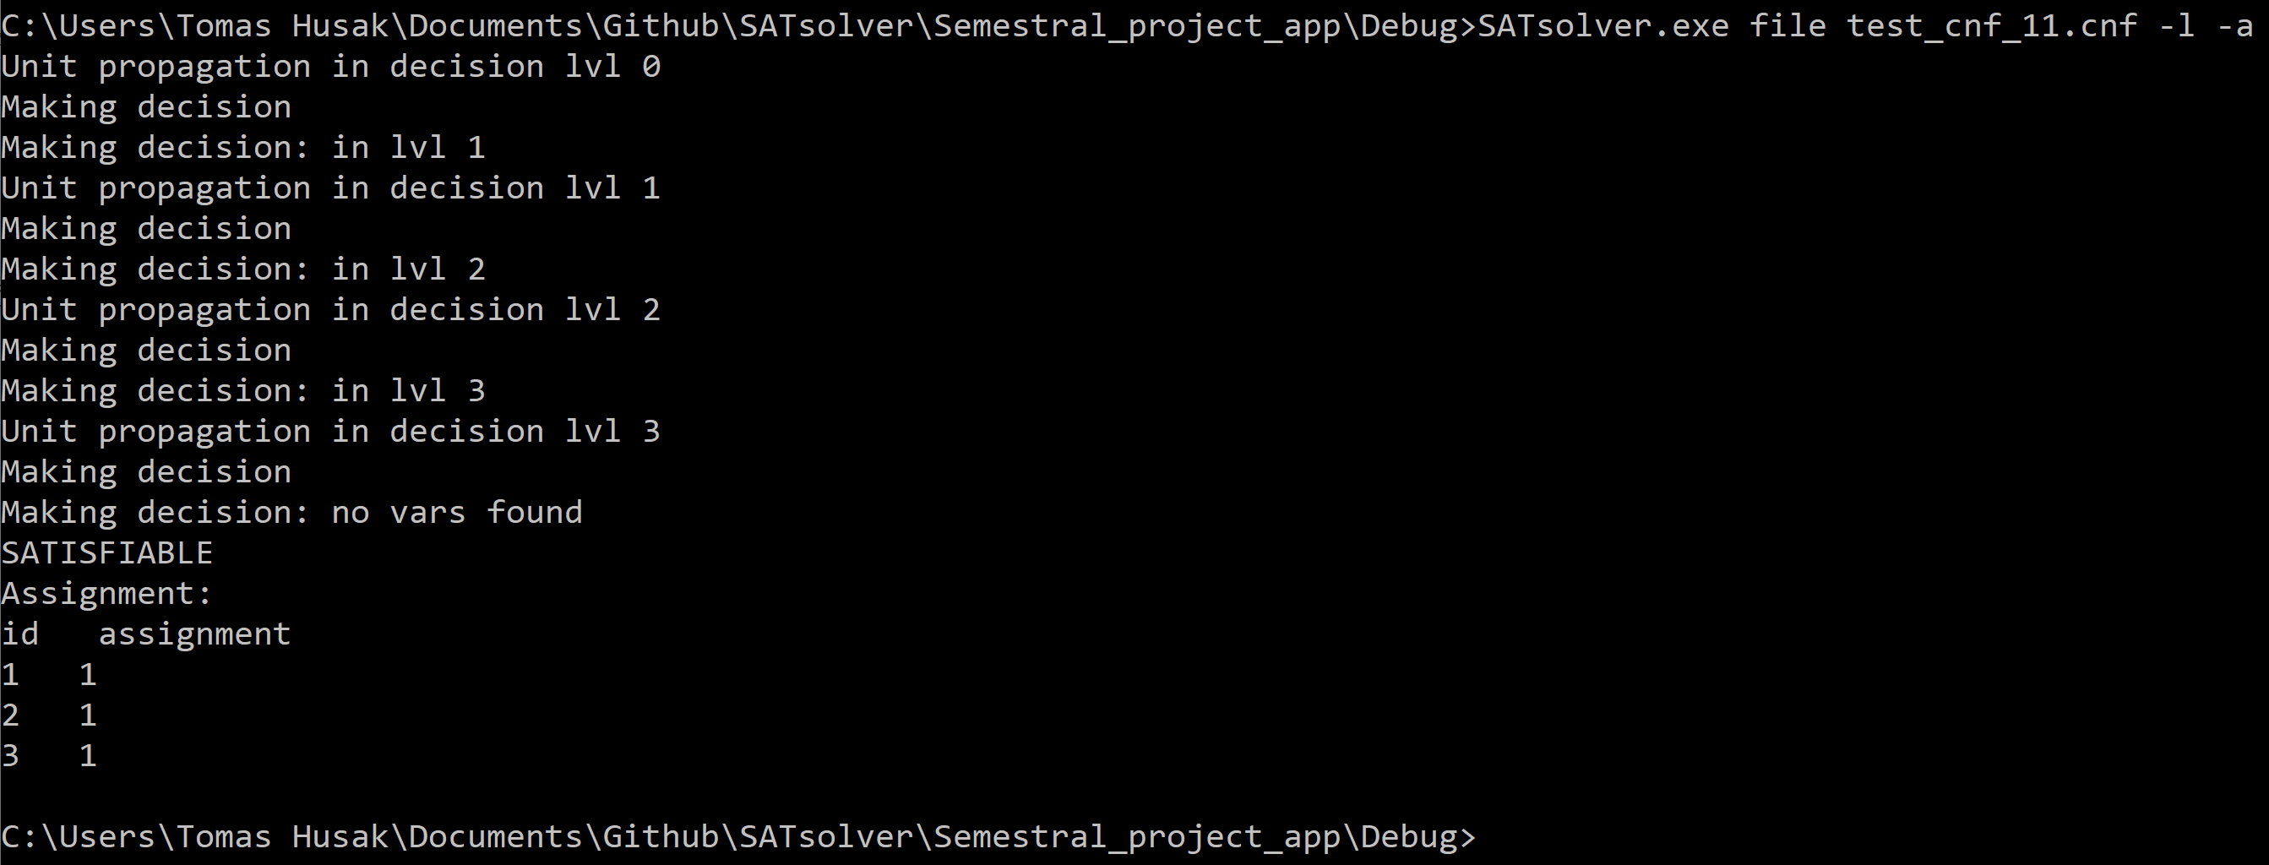

figure 2 - formula sovling